Laboratory Exercise 004

Ocampo, Paolo

1. Write a program that accepts user’s section, and display them back with the format “\*\*\* Section: user’s section\*\*\*”.

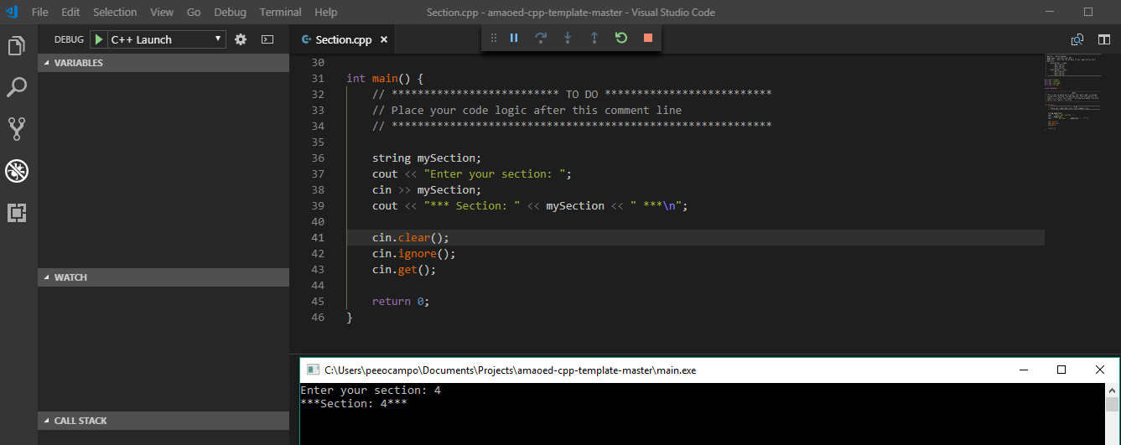

1. Write a program that accepts user’s daily budget and display the product of the daily budget and itself.
2. Write a program that accepts user’s name, password and address and display them back using the format “Hi, I\* am user’s name. I live at user’s address”.

Restrictions:

* Use only three variables.
* Make sure you support spaces.

1. What can you conclude from this activity?